ParkWise: A Smart Parking Management Prototype Using YOLOv8 Vehicle Detection

Krishna Surya Chowdary
Dept. of Computer Science and Engineering
ICFAI University
Hyderabad, India bikkinakrishnasuryachowdary24@ifheindia.org

Abstract—Finding an available parking space in a busy city such as Hyderabad can mean driving around the same streets while waiting for a bay to open. ParkWise is a B.Tech project that brings together an operator dashboard, a parking database and an existing object detector to help manage that process. The system uses a React and Vite interface, a FastAPI backend, SQLAlchemy models and SQLite. For vehicle detection, it runs pretrained Ultralytics YOLOv8 weights through OpenCV. A detection changes a space's status only if its centre falls within a manually defined region of interest. In the project's CPU run using the COCO 2017 benchmark configuration, YOLOv8m recorded 51.96% mAP@0.5:0.95 at about 397 ms per image; YOLOv8n recorded 38.63% at about 52 ms. We also report a separate offline experiment using classical classifiers on 1,726 images of empty and occupied spaces. That experiment is based on one recorded run, so its limits matter. The paper distinguishes working features from demo data and identifies what must change before the prototype can be used with real traffic.
Keywords—smart parking, YOLOv8, vehicle detection, occupancy mapping, region of interest, FastAPI, React

Introduction
Drivers who cannot see which bays are free often keep circling busy commercial areas, adding traffic and wasting fuel [1]. Smart parking systems aim to close that information gap through sensors, cameras or booking services; the field has been widely studied [2].
We built ParkWise as a prototype for exploring this problem in Hyderabad. Operators can use the web app to monitor capacity, update parking records, manage vehicles and reservations, and run detection on images, videos or camera frames. A separate space finder lets drivers search for a bay and make a reservation.
ParkWise remains a prototype. The demand forecast and parts of the analytics page use seeded or static demo data, and some interface features are only partly connected. This paper describes the audited code as it currently works and labels each component by its actual status.
Our main contributions are the following:
- A dashboard prototype that connects React to FastAPI and SQLAlchemy and stores data across 19 persistent entities.
- A YOLOv8 inference path for uploaded images, sampled video frames and configured cameras. A simple region-of-interest (ROI) rule maps detections to parking-space status.
- A CPU comparison of three pretrained YOLOv8 variants, showing the accuracy-speed trade-off in the stored results.
- A code-status audit that separates verified behaviour from demo data and identifies work required before deployment.
Section II reviews related work. Section III describes the architecture, and Section IV covers the detection pipeline. Section V explains the supporting modules, Section VI presents the evaluation and Section VII discusses limitations. Section VIII outlines future work, and Section IX concludes.

Related Work
Lin et al. [2] group smart parking research by how systems collect parking information, deploy them and deliver information to drivers. Sensors installed in every bay provide clear occupancy readings but require hardware at each space. One camera can cover several bays, which has helped make vision-based occupancy detection a common area of study.
Vision-based methods generally take one of two approaches. One classifies image patches for individual bays as empty or occupied. The PKLot dataset [3] provided a benchmark for this task, and Amato et al. [4] showed that a compact convolutional network could run on cameras with limited computing power. The other approach detects vehicles and maps their locations to spaces. YOLO-family single-stage detectors [5] are widely used because of their speed. Ultralytics YOLOv8 [6] comes with weights pretrained on the 80 COCO categories [7], including cars, motorcycles, buses and trucks.
ParkWise uses both approaches in different parts of the project. Its live pipeline detects vehicles and maps their bounding boxes to bays; the offline experiment classifies image patches using classical models [8]–[10] rather than a CNN. We chose a pretrained detector so we could start without labelled ParkWise footage. Car-park route guidance is commonly treated as a shortest-path problem, for which A* [11] is a standard heuristic method. As Section V explains, the current code does not implement A*.

System Architecture
Figure 1 outlines the system. Browser requests pass through FastAPI to SQLAlchemy and SQLite. The AI routes form a separate branch that can write detected occupancy back to the same database.
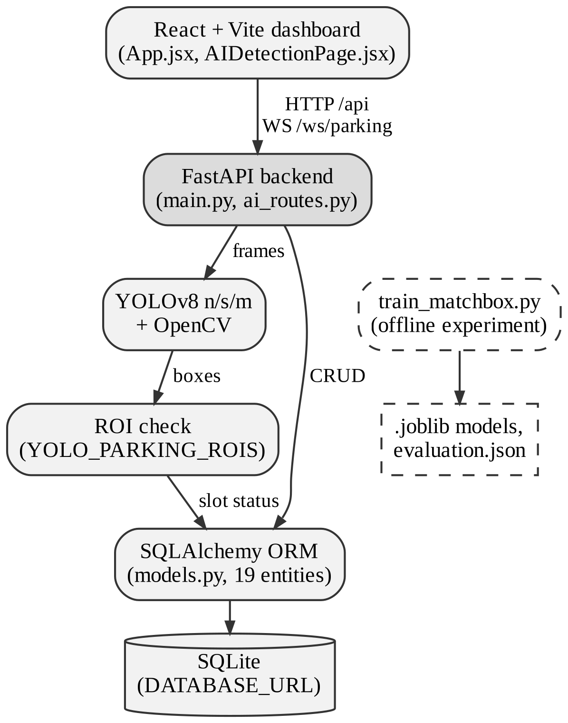
- ParkWise architecture. Dashed boxes mark the offline Matchbox classifier, which has no runtime link to live inference.

Front End
The front end is a single-page app built with React 19, React Router 7 and Vite 8. Most pages are in src/App.jsx; the vehicle-detection page is in src/pages/AIDetectionPage.jsx. Recharts powers the charts, Lucide supplies the icons and plain CSS handles the styling. Each page manages its own state with React hooks and uses thin Axios wrappers grouped by domain in src/api/. There is no global state library. A shared client in src/api/client.js turns timeouts, network failures and HTTP errors into readable messages, so failed requests appear as errors rather than empty tables.
The app's navigation includes login, an overview dashboard, a space finder, a demand forecast, an AI and dataset page, vehicle detection, parking spaces, vehicles, reservations, analytics and settings. In development, Vite proxies /api and /ws to the backend. In deployment, the client uses VITE_API_URL and VITE_WS_URL.

Back End
The backend uses FastAPI [12] with Uvicorn, and Pydantic 2 validates request bodies. Routes are split across two modules. backend/app/main.py creates the app, configures CORS, creates tables and seeds demo data at startup. It also defines the general endpoints for health, dashboard summaries, parking lots and spaces, recommendations, pricing, vehicles, reservations, payments, navigation, analytics, test records and authentication. backend/app/ai_routes.py is mounted at /api/ai/vehicle-detections and handles image, video and camera inference, detection history and model evaluation.
Pricing and recommendation logic currently lives in main.py. This kept the prototype quick to build, but makes those parts harder to test independently. We plan to move them into a service layer. Settings are in backend/app/core/config.py; core/database.py creates the engine and sessions, and core/security.py contains the password-hashing and token helpers.

Data Model
backend/app/models.py defines 19 ORM entities, each with an integer primary key. A parking lot contains levels and spaces; a user owns vehicles and reservations; a vehicle can have reservations and parking sessions; and a session can have a payment. Parking spaces also link to detection records and occupancy history, which records changes made by the vision pipeline. The remaining tables store YOLO evaluations, including metrics and confusion-matrix data as JSON, pricing rules, camera devices, system events, model comparisons and test-case results.
A ParkingSpace row has a unique space_code and stores its lot, level, zone, status, type, accessibility and EV flags, optional current vehicle and coordinates. Seed data and the interface use AVAILABLE, OCCUPIED, RESERVED and HELD. The app creates tables with create_all() at startup. Alembic is configured, but the project has no migration revisions yet.

Vehicle Detection and Occupancy Mapping

Detector
ParkWise uses pretrained YOLOv8 checkpoints (yolov8n.pt, yolov8s.pt and yolov8m.pt) through Ultralytics; it does not define a custom network. Models are cached after loading, and locks guard inference. The predict call filters for the COCO class IDs for car, motorcycle, bus and truck, so other objects do not appear in the response. The code leaves the confidence and IoU thresholds, input size and device unspecified. Ultralytics defaults and automatic device selection therefore apply, and reported speed or accuracy depends on those settings.
The server supports three input paths. OpenCV [13] and NumPy decode uploaded images, which are limited to 100 MB. Uploaded videos are sampled, with at most 600 frames processed; the system writes an annotated MP4 and serves it through an endpoint that checks the file name and type. A camera listed in YOLO_CAMERA_SOURCES can provide one frame on demand. The detection page's browser camera adds a fourth, client-side source. Each response includes detections, annotated previews, timing and an occupancy summary. The system also stores every detection with its inference metadata.

From Boxes to Parking Spaces
A bounding box tells us where a vehicle is in the image, not which bay it is in. We bridge that gap with a deliberately simple rule. The setting YOLO_PARKING_ROIS maps each space_code to a normalized rectangle in the camera view. For a detection with corners (x₁, y₁) and (x₂, y₂), the centre is
c = ((x₁ + x₂) / 2, (y₁ + y₂) / 2) (1)
and the detection is assigned to a space whose rectangle [u₁, u₂] × [v₁, v₂] satisfies
u₁ ≤ c_{x} ≤ u₂ and v₁ ≤ c_{y} ≤ v₂ (2)
The centre uses the same normalized coordinates as the configured rectangle. If a detection lands inside an eligible space's ROI, the system marks that space occupied. After processing a frame, it can mark an eligible space available when no detection falls within its rectangle. It leaves RESERVED and HELD spaces unchanged, so camera input cannot overwrite a booking. Every status change is added to the occupancy history.
This rule has limits. Without a configured ROI, the system logs detections but does not update space status. Each rectangle is tied to a fixed camera view; moving or zooming the camera invalidates the mapping until it is calibrated again. The centre-point test also cannot resolve a vehicle that spans two bays or is heavily obscured by another vehicle.

Supporting Modules

Space Recommendation and Reservations
The space finder calls GET /api/parking/recommend, loads vehicles and spaces, and lets users create reservations through POST /api/reservations. Reservations support create, read, update and delete operations and are stored in the database. The recommendation logic is basic and was built for demonstration. It does not lock a space during booking, and the system cannot yet prevent conflicts between simultaneous requests.

Occupancy-Tier Pricing
GET /api/pricing/current returns an hourly rate that determine_price_rate() selects from the current occupancy percentage. Table I lists the tiers. A value on a boundary moves to the higher tier, so 40% occupancy costs INR 30. Similar tiers are seeded in pricing_rules, but the helper uses hard-coded values and ignores those rows; changing a database rule therefore has no effect on the price. This is fixed tiered pricing, not pricing that adapts through a learned model. The system can create and list payment records, but it has no payment gateway.
- Occupancy-Tier Hourly Rates
Current occupancy | Rate (INR/h)
Below 40% | 20
40% to below 70% | 30
70% to below 90% | 40
90% to 100% | 50
- Hard-coded in main.py; seeded pricing_rules rows are not read by the helper.

Route Search
POST /api/navigation/route returns a list of nodes between a start and a goal. Although the function is named a_star(), it uses a FIFO queue without a heuristic or edge costs, so it performs breadth-first search. On an unweighted graph, breadth-first search still finds a path with the fewest edges, making the output usable. It is not A* [11], and some route details come from static fallback values. We therefore do not describe the current implementation as A*.

Offline Matchbox Classifier
The separate Matchbox experiment uses 1,726 parking images and the script backend/train_matchbox.py. Of those images, 908 show empty spaces and 818 show occupied spaces. Each image is reduced to a 32×32 RGB representation, with a 16-bin histogram for each colour channel added to the feature vector. A stratified 70/15/15 split feeds four classifiers: a decision tree, a random forest [8], a linear SVM and XGBoost [9]. The models are built with scikit-learn [10] and the XGBoost library. The fitted models, scaler and evaluation.json are saved under data/matchbox_evaluation/.
The camera path does not load any of these artifacts. Matchbox remains an offline experiment and does not contribute to live occupancy detection. Some interface text mentions a CNN, but the project has not implemented one.

Analytics, Forecast and Live Updates
The overview dashboard reads live totals and occupancy from the database. The demand forecast uses a 16-row CSV of sample hourly values, while parts of the occupancy and revenue analytics return static arrays. The forecast page identifies its output as demo data. The monitoring page opens a WebSocket at /ws/parking, but the server only echoes messages; it does not broadcast space changes. The interface stays current through periodic polling.

Evaluation

Datasets
We evaluate the detector on a COCO 2017 [7] validation bundle stored in data/coco_vehicle_benchmark/. It contains 5,000 JPEG images and 36,781 annotations across all 80 COCO categories. The four runtime classes account for 1,932 car annotations, 371 motorcycle annotations, 285 bus annotations and 415 truck annotations. These are object counts, not image counts. The dataset YAML defines separate validation and test lists of 500 images each, with no overlap. We have no ParkWise-specific camera dataset for the detector, which limits how directly these results apply to the project.
Section V-D describes the Matchbox images, but the code base does not document their source or how they were collected.

YOLOv8 Results
Table II and Fig. 2 report the stored evaluation of the three bundled checkpoints on a CPU. Precision P, recall R and mAP come from Ultralytics validation, and F1 is their harmonic mean:
F1 = 2PR / (P + R) (3)
- Stored CPU Evaluation of Pretrained YOLOv8 Checkpoints
Model | P | R | F1 | mAP 0.5 | mAP 0.5:0.95 | Time (ms) | FPS
YOLOv8n | 59.95 | 49.03 | 53.94 | 53.50 | 38.63 | 52.4 | 19.08
YOLOv8s | 67.62 | 55.67 | 61.07 | 62.05 | 45.60 | 154.6 | 6.47
YOLOv8m | 71.53 | 61.99 | 66.42 | 68.78 | 51.96 | 397.4 | 2.52
- P, R, F1 and mAP in %. COCO 2017 configuration with all 80 classes; values from the root parkwise.db snapshot, times rounded.
Across the three bundled models, mAP@0.5:0.95 rises from 38.63% with YOLOv8n to 51.96% with YOLOv8m, a gain of about 13.3 points. Mean inference time also rises, from about 52 ms to about 397 ms per image, making YOLOv8m roughly 7.6 times slower. That corresponds to 19.1 FPS for YOLOv8n and 2.5 FPS for YOLOv8m. ParkWise selects YOLOv8m because it has the highest mAP@0.5:0.95. That choice suits a parking camera that needs an update every few seconds; YOLOv8n is more practical for CPU use close to real time. We omit YOLOv8l because the project does not include that checkpoint.
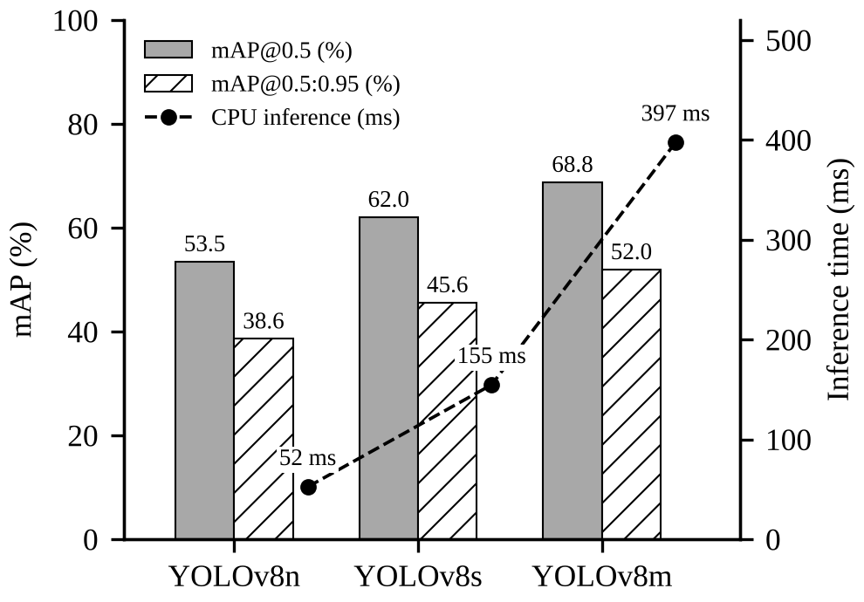
- Stored CPU evaluation of the bundled YOLOv8 checkpoints. Bars show mAP (left axis); the dashed line shows mean inference time per image (right axis).
These results need two qualifications. The evaluation uses all 80 COCO categories, while live inference keeps only four vehicle classes. It therefore measures general detection performance, not vehicle-only accuracy in a parking lot. Results also depend on the CPU, library versions and default settings, and the run has not been repeated on other hardware. We do not report accuracy for this detector because accuracy is not a suitable metric for bounding-box detection.

Matchbox Classifier Results
Table III shows the scores recorded in evaluation.json for one run on a 259-image test split. The random forest scored 100%, XGBoost 99.23%, the decision tree 94.98% and the linear SVM 83.78%.
- Recorded Matchbox Classifier Test Accuracy
Classifier | Accuracy (%)
Random forest | 100.00
XGBoost | 99.23
Decision tree | 94.98
Linear SVM | 83.78
- Single stored run on 259 test images; not independently reproduced.
These scores come from one split, have not been independently reproduced, and were not tested on footage from a real ParkWise site. A perfect result on 259 small images does not show how the classifier would handle shadows, rain or a different camera angle. Before relying on the result, we should check the split for near-duplicate images.

Software Checks
The project currently has one backend test module, backend/tests/test_ai_routes.py, with three tests. In the latest recorded run, two passed and one failed because the test still calls _detection_metrics with two arguments; the helper now also requires model_names and target_counts. Frontend lint and the production build passed, although the build warned about a large JavaScript chunk. The backend compiled without syntax errors. No frontend unit-test suite or field measurements of occupancy accuracy and deployment throughput are available yet.

Implementation Status and Limitations
Table IV uses status labels from the code audit. Several broader issues also affect the system.
- Implementation Status of ParkWise Components
Component | Status
Dashboard, inventory, vehicles, reservations | Implemented, unverified
YOLO image and video inference | Implemented, unverified
YOLO evaluation and comparison | Implemented and verified
Browser and configured cameras | Partial
Detection-to-space ROI mapping | Partial
Login, password hashing, JWT | Partial
WebSocket live updates | Partial (echo only)
Route search labelled A* | Partial (breadth-first)
Matchbox classifier | Offline experiment
Occupancy-tier pricing | Demo (fixed tiers)
Demand forecast, analytics | Demo data
Payment ledger | Demo (no gateway)
CNN, OCR/ANPR, Dijkstra, RL | Not implemented
Database migrations | Not implemented
Production deployment | Unknown
- Labels follow the code audit; the Matchbox entry is implemented as an offline script only.
Split database. The default DATABASE_URL is the relative path sqlite:///./parkwise.db, so Uvicorn uses a different file depending on its launch directory. Two populated copies exist. The root database contains 20 spaces, 5 vehicles, 3 reservations and 3 YOLO evaluation rows. backend/parkwise.db contains 20 spaces, 5 vehicles, 11 reservations and 7 test cases, but no evaluation rows. As a result, the dashboard can show different data depending on where the server starts. Setting one absolute database path is our first fix.
Authentication. Login, registration, password hashing and token creation are implemented. Most API routes do not require a validated bearer token, though, and the Axios client does not send one. The front-end route guard checks only for a token marker in localStorage. The backend also uses a development SECRET_KEY if no key is supplied. Authentication currently controls the interface but does not protect API access.
Dataset hygiene. The COCO YAML points its training path to the full val2017 directory, which also supplies the validation and test lists. The pretrained weights and current project do not use this training path, so the recorded results are unaffected. Fine-tuning with the YAML as written would, however, put evaluation images in the training data.
Calibration and demo data. ROI rectangles are set by hand; the system has no automatic bay segmentation or camera calibration. Some analytics pages use seeded values despite looking operational, so the dashboard should clearly identify which figures come from live records.

Future Work
We plan to start with the issues that keep us from trusting the results. First, set an absolute DATABASE_URL for all launch modes, update the stale test, and add route and schema tests for uploads, ROI updates and malformed input. Then implement authentication properly: reject the development secret in production, validate bearer tokens on protected routes, and enforce ownership by user and role. An initial Alembic revision can replace create_all() and give the project a safe way to evolve the schema.
Before fine-tuning, we will create disjoint training, validation and test splits and evaluate vehicle classes only, ideally using footage from a real Hyderabad car park. Each camera's ROI settings need validation, with tests for every status transition; camera errors should also be visible to operators. We will either integrate Matchbox as a second occupancy-detection path and validate it properly, or label it clearly as offline research.
After that, we can replace the remaining demo features. Analytics should use timestamped records, and a forecast model should wait until real history exists. Route search needs a weighted graph and a correct A* or Dijkstra implementation; pricing should load rules from the database, and the WebSocket should broadcast space changes. A reproducible deployment with HTTPS, restricted CORS, backups and load testing comes later.

Conclusion
ParkWise brings a web application, a relational data model and a pretrained YOLOv8 detector together in a working student prototype. The current implementation is strongest in database-backed record management and detection across images, videos and camera frames. In the stored CPU comparison, YOLOv8m gains about 13 points of mAP@0.5:0.95 over YOLOv8n, with roughly 7.6 times the inference latency. The detector updates parking-space status only through manually placed regions of interest.
The forecast, much of the analytics, tiered pricing, route planning and live updates still rely on demo or partial implementations. Before deployment, the project also needs a single database configuration, stronger API authorization and schema migrations. These limitations set out what must be addressed before ParkWise can be treated as a finished smart-parking system.

Acknowledgment
The authors thank [project guide name], Department of Computer Science and Engineering, [College Name], Hyderabad, for guidance and feedback throughout this project.

References
- D. C. Shoup, “Cruising for parking,” Transport Policy, vol. 13, no. 6, pp. 479–486, Nov. 2006.
- T. Lin, H. Rivano, and F. Le Mouël, “A survey of smart parking solutions,” IEEE Trans. Intell. Transp. Syst., vol. 18, no. 12, pp. 3229–3253, Dec. 2017.
- P. R. L. de Almeida, L. S. Oliveira, A. S. Britto Jr., E. J. Silva Jr., and A. L. Koerich, “PKLot: A robust dataset for parking lot classification,” Expert Syst. Appl., vol. 42, no. 11, pp. 4937–4949, 2015.
- G. Amato, F. Carrara, F. Falchi, C. Gennaro, C. Meghini, and C. Vairo, “Deep learning for decentralized parking lot occupancy detection,” Expert Syst. Appl., vol. 72, pp. 327–334, 2017.
- J. Redmon, S. Divvala, R. Girshick, and A. Farhadi, “You only look once: Unified, real-time object detection,” in Proc. IEEE Conf. Comput. Vis. Pattern Recognit. (CVPR), 2016, pp. 779–788.
- G. Jocher, A. Chaurasia, and J. Qiu, “Ultralytics YOLOv8,” 2023. [Online]. Available: https://github.com/ultralytics/ultralytics
- T.-Y. Lin et al., “Microsoft COCO: Common objects in context,” in Proc. Eur. Conf. Comput. Vis. (ECCV), 2014, pp. 740–755.
- L. Breiman, “Random forests,” Mach. Learn., vol. 45, no. 1, pp. 5–32, 2001.
- T. Chen and C. Guestrin, “XGBoost: A scalable tree boosting system,” in Proc. 22nd ACM SIGKDD Int. Conf. Knowl. Discov. Data Min., 2016, pp. 785–794.
- F. Pedregosa et al., “Scikit-learn: Machine learning in Python,” J. Mach. Learn. Res., vol. 12, pp. 2825–2830, 2011.
- P. E. Hart, N. J. Nilsson, and B. Raphael, “A formal basis for the heuristic determination of minimum cost paths,” IEEE Trans. Syst. Sci. Cybern., vol. 4, no. 2, pp. 100–107, Jul. 1968.
- S. Ramírez, “FastAPI,” software documentation. [Online]. Available: https://fastapi.tiangolo.com
- G. Bradski, “The OpenCV library,” Dr. Dobb’s J. Softw. Tools, vol. 25, no. 11, pp. 120–125, 2000.

